Ex. No. 9 | Modern User Interface Design using ReactJS
Date of Exercise | 09.11.2026
GitHub Host Link | https://praneettigga.github.io/web-tech-lab/
Aim
To design and implement a modern, responsive and interactive User Interface (UI) dashboard in ReactJS using functional components, the useState hook, props-driven component composition and CSS theme switching.
Description
Component-driven architecture: The interface is split into small reusable components (Header, StatCard and TaskList). Each receives its data and callbacks as props, so one StatCard definition renders all three statistic cards.
Declarative state management: The useState hook holds the theme, the text of the task input and the list of tasks. When a setter such as setTheme or setTasks is called, React re-renders only the affected elements through the Virtual DOM. State is updated immutably, using map, filter and the spread operator.
Props and events: Data flows down from App to its children as props, and user actions flow back up through callback props (toggleTheme, onToggleTask, onDeleteTask). Controlled inputs use value and onChange, and the form uses onSubmit with event.preventDefault().
Conditional rendering: Ternary expressions and className template strings choose the theme label, the positive or negative badge (▲ / ▼), the strike-through on completed tasks and the empty-state message.
CSS theme switching: The colours are defined as CSS custom properties (--bg-primary, --bg-card, --text-primary and so on). Adding the class dark to the root element redefines them, and a transition on background-color and color animates the change.
Responsive layout: CSS Grid with repeat(auto-fit, minmax(260px, 1fr)) lets the statistic cards reflow across desktop, tablet and mobile widths, while Flexbox aligns the header, the task form and the task rows.
Micro-interactions: Checkboxes, delete buttons, the theme toggle and the live list update give immediate feedback, which improves usability and accessibility.
Procedure:
1. Select the application to be built: a modern dashboard with statistic cards, a project milestone list and a light/dark theme switch.
2. Install Node.js and create a React project using Vite (npm create vite@latest, template react), then run npm install.
3. Create the folder Expt9 containing index.html, vite.config.js and the src folder with main.jsx, App.jsx and App.css.
4. In App.jsx, write the Header component, which receives theme, toggleTheme and userName as props and shows the theme toggle button.
5. Write the StatCard component, which receives title, value, change, isPositive and icon as props and shows a green or red badge.
6. Write the TaskList component, which maps the tasks array to list items with a checkbox and a delete button, and shows an empty-state message when the array is empty.
7. In the App component, declare the state with useState: theme, taskInput and tasks.
8. Write toggleTheme, handleAddTask, handleToggleTask and handleDeleteTask, each updating the state immutably.
9. Return the JSX: the root div with the theme class, the Header, three StatCard components and the task form with the TaskList.
10. In App.css, define the colour variables, the .dark overrides, the grid and flex layouts, the card styles and the badge styles.
11. Run npm run dev (or npm run build and npm run preview) and test the theme toggle, adding, completing and deleting tasks.
12. Push the code to GitHub and host it using GitHub Pages.
Program
index.html
<!doctype html>
<html lang="en">
<head>
<meta charset="UTF-8" />
<link rel="icon" type="image/svg+xml" href="./favicon.svg" />
<meta name="viewport" content="width=device-width, initial-scale=1.0" />
<title>ModernUI Dashboard</title>
</head>
<body>
<div id="root"></div>
<script type="module" src="/src/main.jsx"></script>
</body>
</html>

src/main.jsx
import { StrictMode } from 'react'
import { createRoot } from 'react-dom/client'
import './index.css'
import App from './App.jsx'

createRoot(document.getElementById('root')).render(
<StrictMode>
<App />
</StrictMode>,
)

src/App.jsx
import React, { useState } from "react";
import "./App.css";

// Reusable Header Component
const Header = ({ theme, toggleTheme, userName }) => {
return (
<header className="app-header">
<div className="brand">
<h2>⚡ ModernUI Dashboard</h2>
</div>
<div className="header-actions">
<span>Welcome, <strong>{userName}</strong></span>
<button className="theme-toggle-btn" onClick={toggleTheme}>
{theme === "light" ? "🌙 Dark Mode" : "☀️ Light Mode"}
</button>
</div>
</header>
);
};

// Reusable Stat Card Component
const StatCard = ({ title, value, change, isPositive, icon }) => {
return (
<div className="stat-card">
<div className="stat-header">
<span className="stat-icon">{icon}</span>
<span className="stat-title">{title}</span>
</div>
<div className="stat-body">
<h3 className="stat-value">{value}</h3>
<span className={`stat-badge ${isPositive ? "positive" : "negative"}`}>
{isPositive ? "▲" : "▼"} {change}
</span>
</div>
</div>
);
};

// Interactive Task List Component
const TaskList = ({ tasks, onToggleTask, onDeleteTask }) => {
return (
<div className="task-container">
<h3>Project Milestones</h3>
<ul className="task-list">
{tasks.length === 0 ? (
<li className="empty-state">No active milestones found.</li>
) : (
tasks.map((task) => (
<li key={task.id} className={`task-item ${task.completed ? "completed" : ""}`}>
<label className="task-label">
<input
type="checkbox"
checked={task.completed}
onChange={() => onToggleTask(task.id)}
/>
<span>{task.title}</span>
</label>
<button className="delete-btn" onClick={() => onDeleteTask(task.id)}>
✕
</button>
</li>
))
)}
</ul>
</div>
);
};

// Main Modern UI Application Component
export default function App() {
const [theme, setTheme] = useState("light");
const [taskInput, setTaskInput] = useState("");
const [tasks, setTasks] = useState([
{ id: 1, title: "Design Component Wireframes", completed: true },
{ id: 2, title: "Build Responsive Layout System", completed: false },
{ id: 3, title: "Optimize Dark/Light Theme Switching", completed: false },
]);

const toggleTheme = () => {
setTheme((prev) => (prev === "light" ? "dark" : "light"));
};

const handleAddTask = (e) => {
e.preventDefault();
if (!taskInput.trim()) return;
const newTask = {
id: Date.now(),
title: taskInput.trim(),
completed: false,
};
setTasks([...tasks, newTask]);
setTaskInput("");
};

const handleToggleTask = (id) => {
setTasks(
tasks.map((task) =>
task.id === id ? { ...task, completed: !task.completed } : task
)
);
};

const handleDeleteTask = (id) => {
setTasks(tasks.filter((task) => task.id !== id));
};

return (
<div className={`app-root ${theme}`}>
<Header theme={theme} toggleTheme={toggleTheme} userName="Alex Vance" />

<main className="dashboard-content">
<section className="stats-grid">
<StatCard
title="Total Revenue"
value="$48,250"
change="14.2%"
isPositive={true}
icon="💼"
/>
<StatCard
title="Active Sessions"
value="2,840"
change="8.6%"
isPositive={true}
icon="👥"
/>
<StatCard
title="Bounce Rate"
value="21.4%"
change="2.1%"
isPositive={false}
icon="📉"
/>
</section>

<section className="task-section">
<form className="task-form" onSubmit={handleAddTask}>
<input
type="text"
placeholder="Add a new milestone..."
value={taskInput}
onChange={(e) => setTaskInput(e.target.value)}
/>
<button type="submit">Add Task</button>
</form>

<TaskList
tasks={tasks}
onToggleTask={handleToggleTask}
onDeleteTask={handleDeleteTask}
/>
</section>
</main>
</div>
);
}

src/App.css
:root {
--bg-primary: #f8fafc;
--bg-card: #ffffff;
--text-primary: #0f172a;
--text-secondary: #64748b;
--accent-color: #2563eb;
--border-color: #e2e8f0;
}

.app-root.dark {
--bg-primary: #0f172a;
--bg-card: #1e293b;
--text-primary: #f8fafc;
--text-secondary: #94a3b8;
--accent-color: #3b82f6;
--border-color: #334155;
}

.app-root {
min-height: 100vh;
background-color: var(--bg-primary);
color: var(--text-primary);
font-family: system-ui, -apple-system, sans-serif;
transition: background-color 0.3s ease, color 0.3s ease;
}

.app-header {
display: flex;
justify-content: space-between;
align-items: center;
padding: 1rem 2rem;
background: var(--bg-card);
border-bottom: 1px solid var(--border-color);
}

.header-actions {
display: flex;
align-items: center;
gap: 1rem;
}

.theme-toggle-btn {
padding: 0.5rem 1rem;
border-radius: 8px;
border: 1px solid var(--border-color);
background: transparent;
color: var(--text-primary);
cursor: pointer;
font-weight: 500;
}

.dashboard-content {
max-width: 1100px;
margin: 2rem auto;
padding: 0 1rem;
}

.stats-grid {
display: grid;
grid-template-columns: repeat(auto-fit, minmax(260px, 1fr));
gap: 1.5rem;
margin-bottom: 2rem;
}

.stat-card {
background: var(--bg-card);
padding: 1.5rem;
border-radius: 12px;
border: 1px solid var(--border-color);
}

.stat-header {
display: flex;
align-items: center;
gap: 0.5rem;
color: var(--text-secondary);
font-size: 0.9rem;
}

.stat-body {
display: flex;
justify-content: space-between;
align-items: baseline;
margin-top: 0.5rem;
}

.stat-badge {
font-size: 0.85rem;
font-weight: 600;
padding: 0.2rem 0.5rem;
border-radius: 6px;
}

.stat-badge.positive { color: #16a34a; background: rgba(22, 163, 74, 0.1); }
.stat-badge.negative { color: #dc2626; background: rgba(220, 38, 38, 0.1); }

.task-section {
background: var(--bg-card);
padding: 1.5rem;
border-radius: 12px;
border: 1px solid var(--border-color);
}

.task-form {
display: flex;
gap: 0.5rem;
margin-bottom: 1.5rem;
}

.task-form input {
flex: 1;
padding: 0.75rem 1rem;
border-radius: 8px;
border: 1px solid var(--border-color);
background: var(--bg-primary);
color: var(--text-primary);
}

.task-form button {
padding: 0.75rem 1.5rem;
background: var(--accent-color);
color: #ffffff;
border: none;
border-radius: 8px;
font-weight: 600;
cursor: pointer;
}

.task-list {
list-style: none;
padding: 0;
margin: 0;
}

.task-item {
display: flex;
justify-content: space-between;
align-items: center;
padding: 0.75rem 0;
border-bottom: 1px solid var(--border-color);
}

.task-item.completed span {
text-decoration: line-through;
color: var(--text-secondary);
}

.delete-btn {
background: none;
border: none;
color: #dc2626;
cursor: pointer;
font-size: 1.1rem;
}

Output
Dashboard in Light Mode
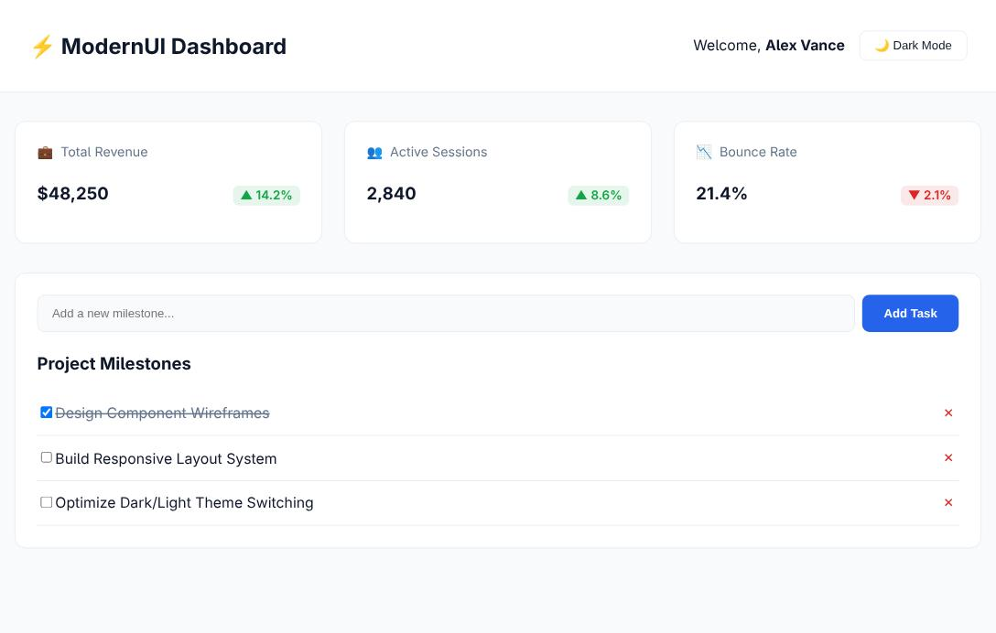
Figure 1: Dashboard in Light Mode
Dashboard in Dark Mode with a newly added task
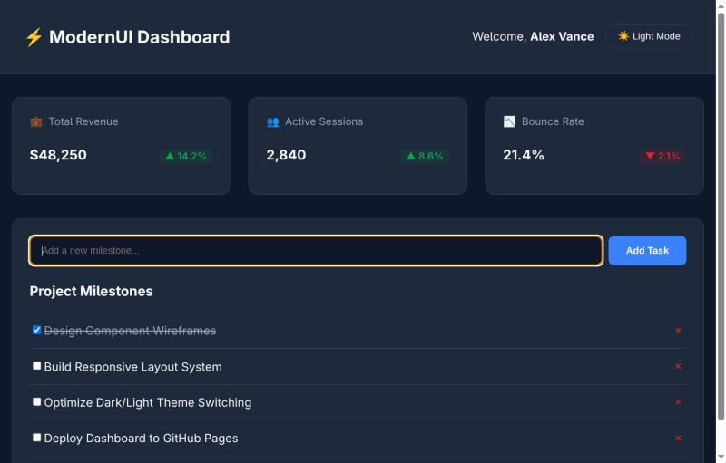
Figure 2: Dashboard in Dark Mode with a newly added task
Result
The modern dashboard was successfully designed and executed in ReactJS using reusable functional components, props, the useState hook and CSS custom properties. The theme switched between light and dark, new milestones were added, completed and deleted with immediate re-rendering, and the layout adapted to the screen width.

